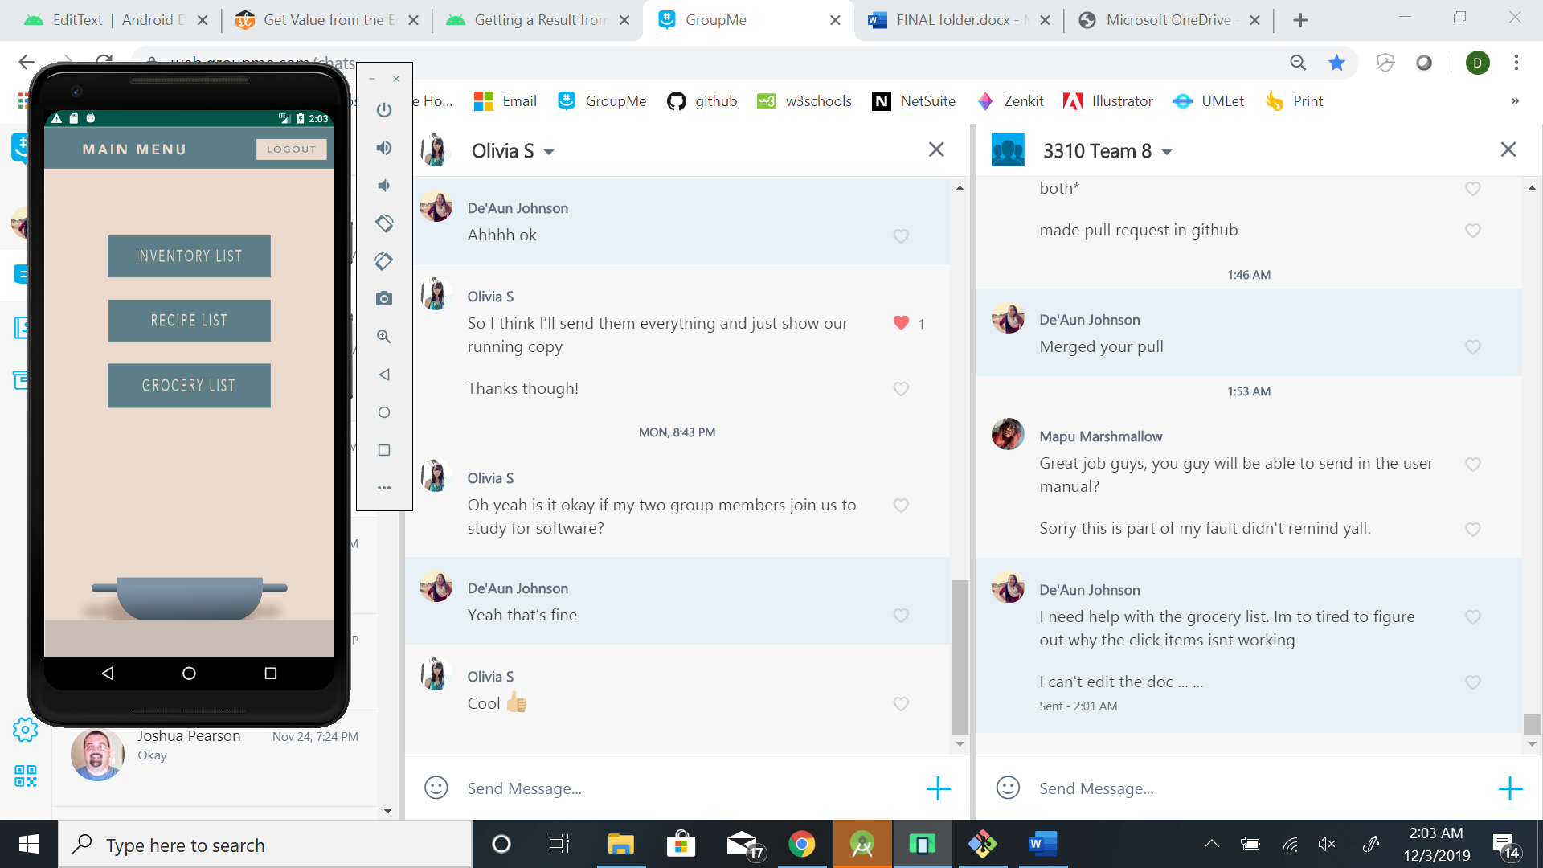

Click Inventory to see list of ingredients in kitchen

Click Grocery List to see list of ingredients in needed to buy

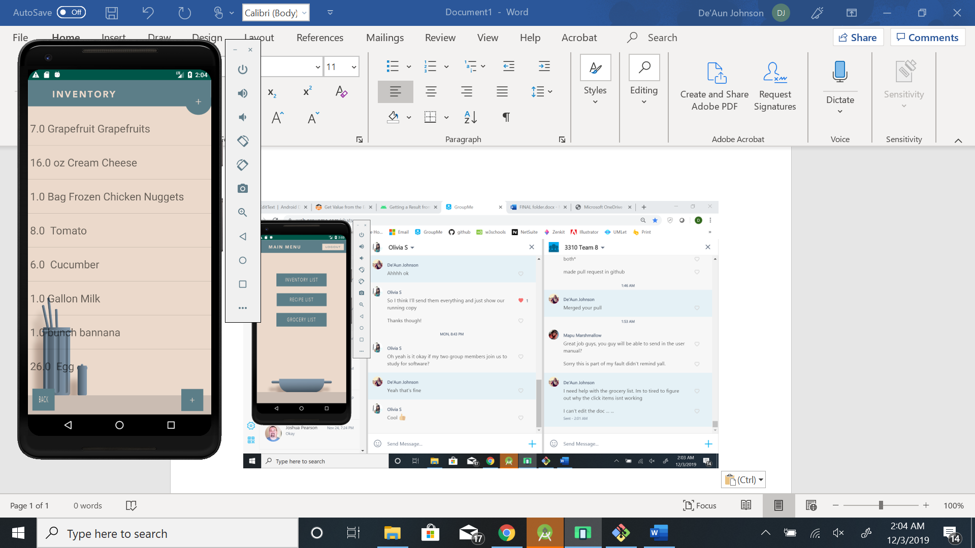

Click any item to view and edit.

Click here to go back to main menu

Click here to add new item to your inventory

Click here to add new user to your inventory

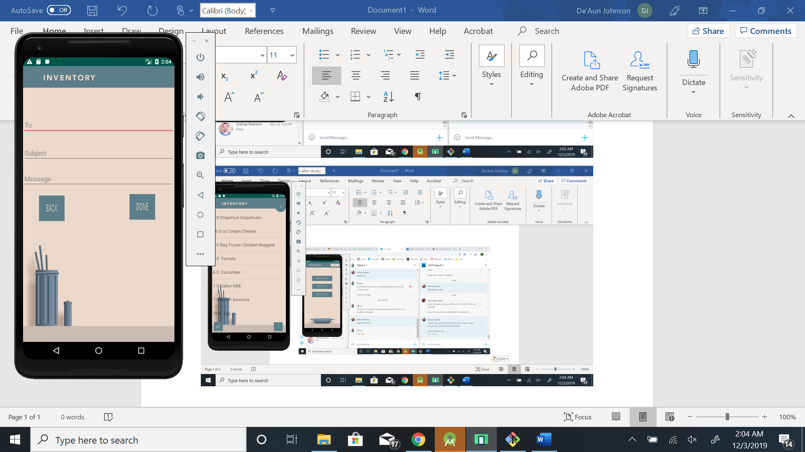

Click here to open email client. Fill out fields in the app or in the email client itself

Click here to go back to main menu

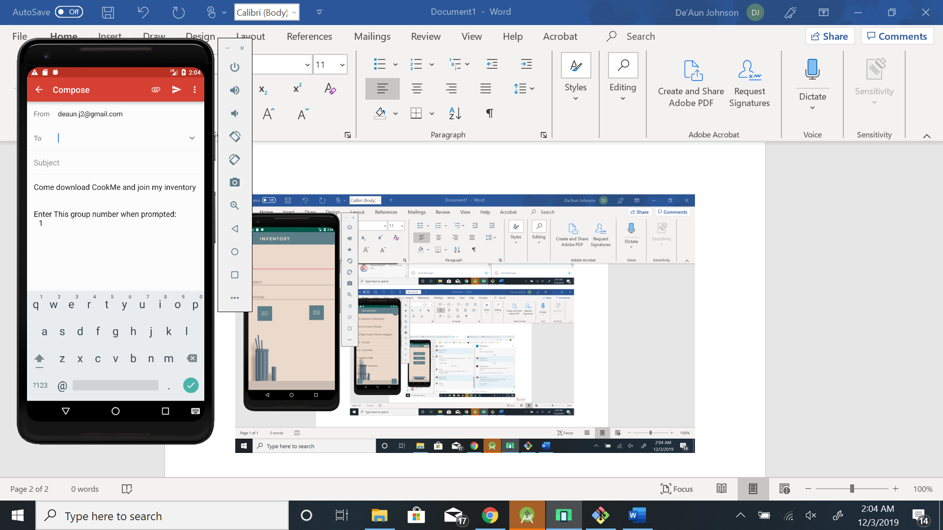

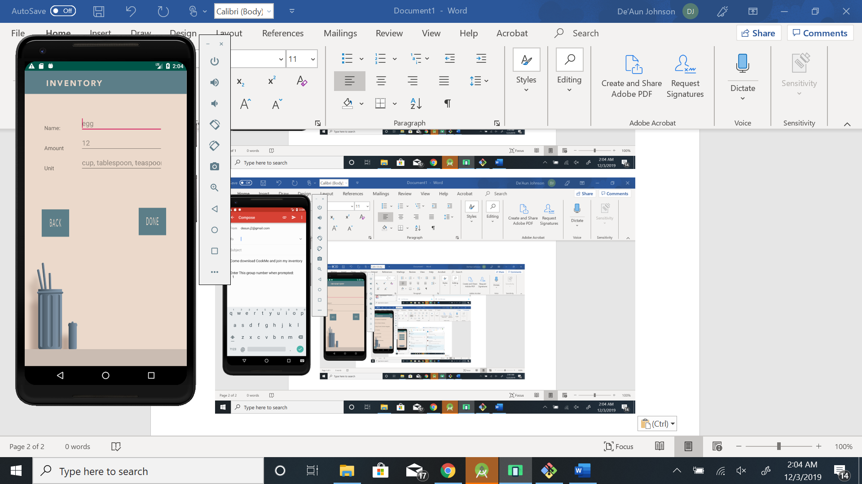

Insert Item information here

Click here to add new item to your inventory

Click here to go back to main menu

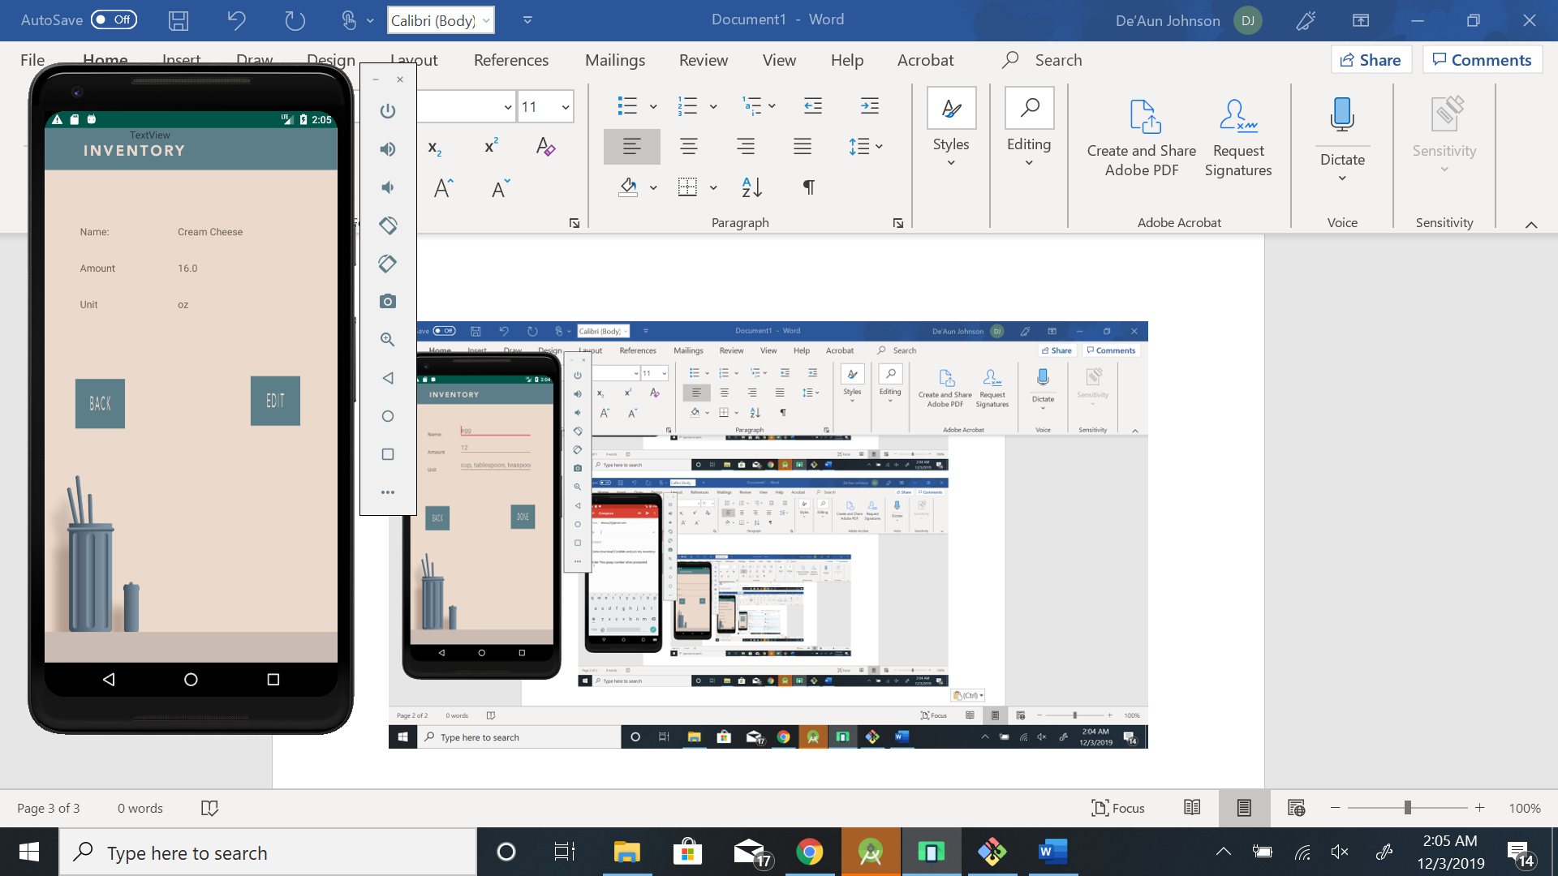

Click here to go back to main menu

Click here to edit information

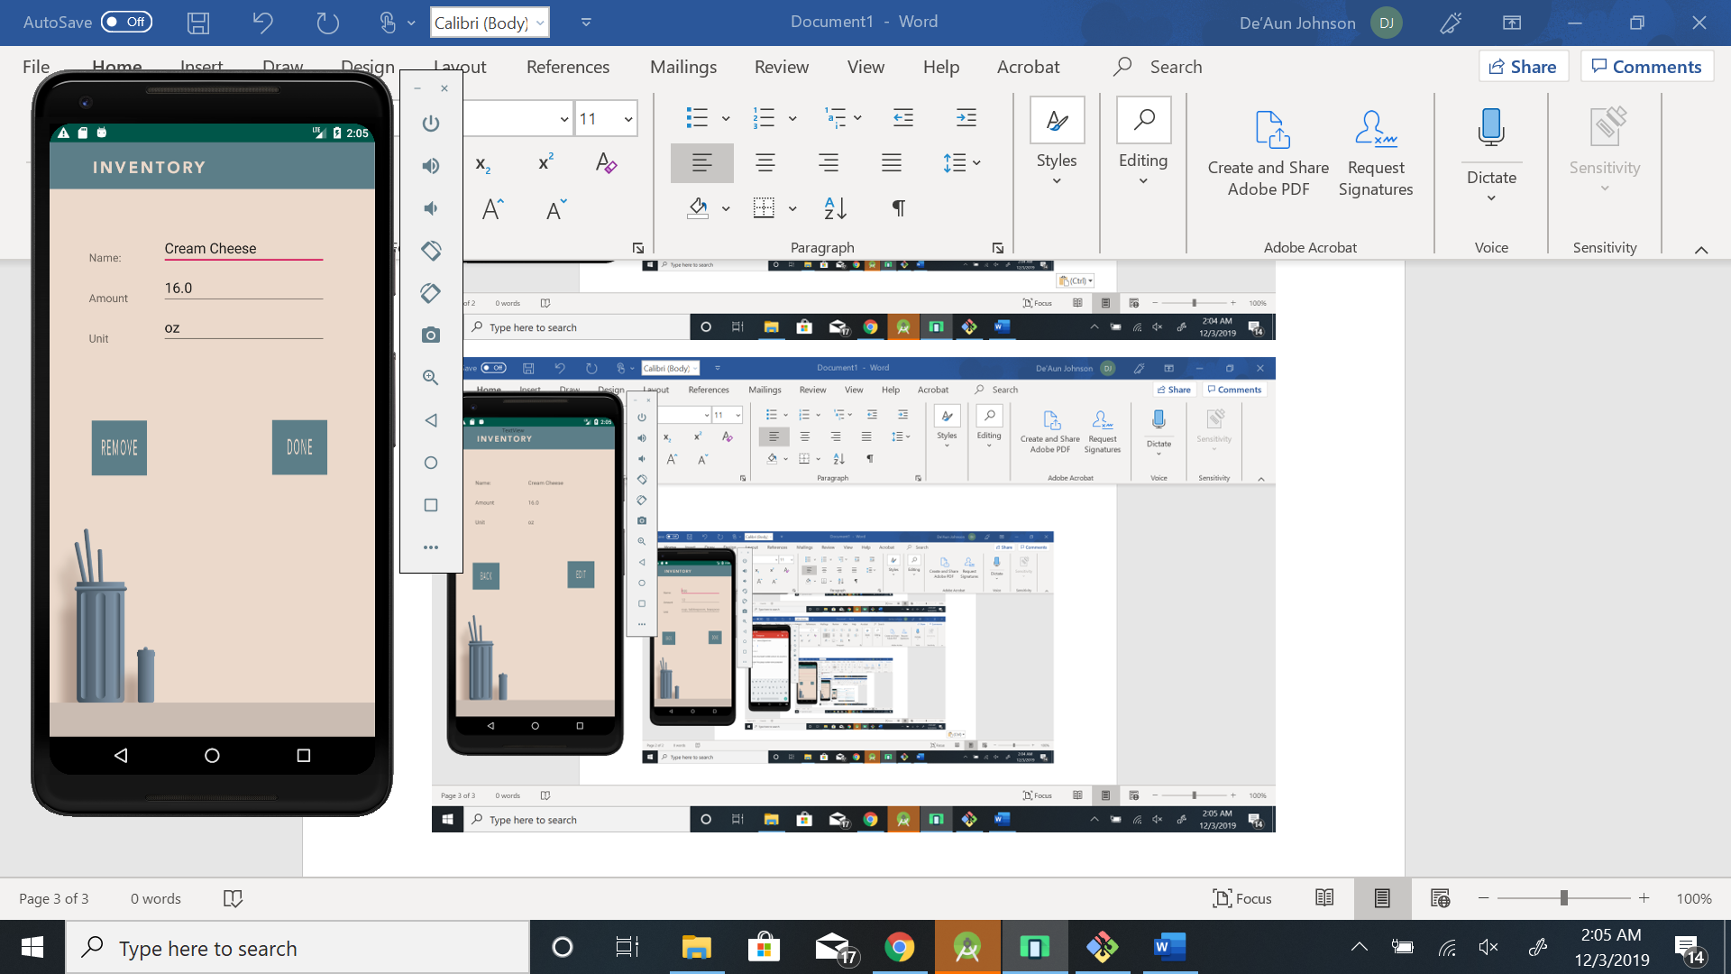

Click here to update item in your inventory

Click here to remove item from inventory

Insert Item information here